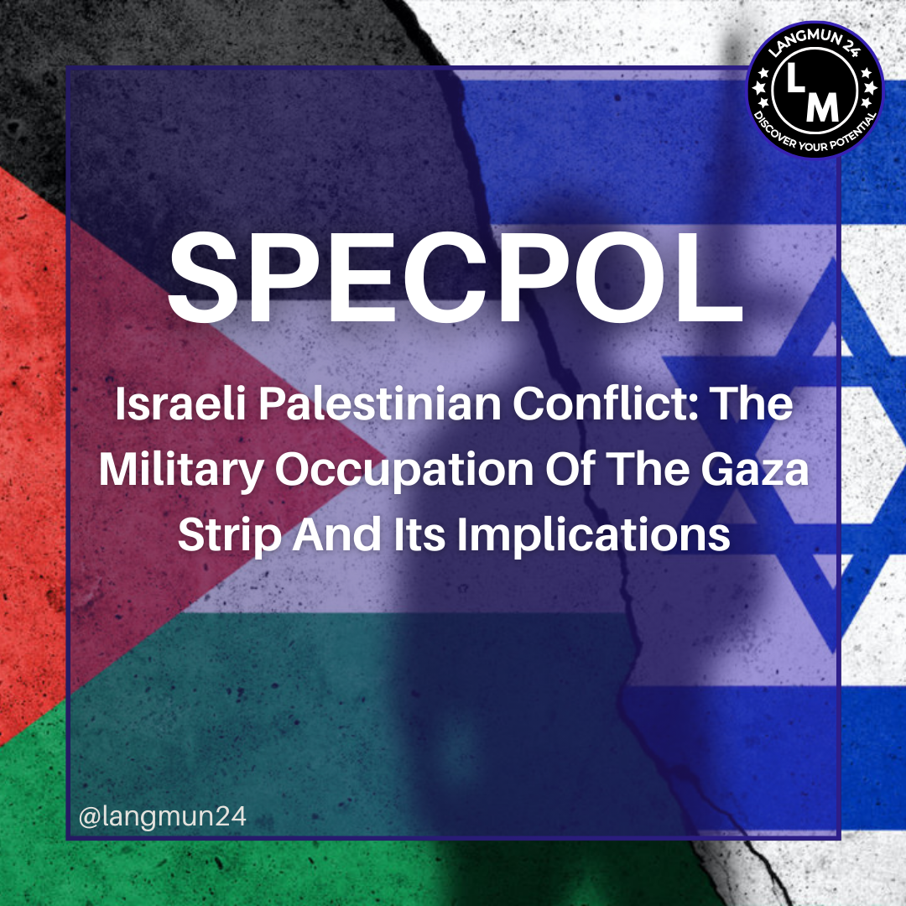

Conference: LANGMUN 24

Committee: Special Political and Decolonization (Fourth Committee)

Agenda Item: Israeli Palestinian Conflict: The Military Occupation of the Gaza Strip and Its Implications

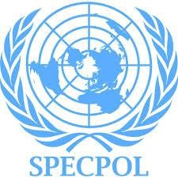**TABLE OF CONTENT**

1. **Introduction**
   1. **Letter from Secretary General**
   2. **Letter from Under Secretary General**
   3. **What is The United Nations General Assembly Fourth Committee**

**(Special Political and Decolonization Committee)**



1. **Violation of International Human Rights in Armed Conflicts**
   1. **What is International Human Rights Law**
   2. **War Crimes**
2. **Introduction of The Agenda Item**
   1. **What is Israel Palestine Conflict**
   2. **War Crimes in Israel Palestine Conflict**
   3. **Process of Peace**
3. **The Situation of Main Countries**
4. **Recommended Sources**
5. **Questions to Pounders**
6. **Bibliography**
7. **Introduction**
   1. **Letter from Secretary General**

Most Esteemed Delegates of LANGMUN24,

I, as the Secretary General of LANGMUN24, am delighted to welcome you to the first iteration of Lang-Up Academy Model United Nations. I am pleased to present to you the fruits of our labour, which we have been preparing for several months. My team has worked tirelessly to deliver the best of unforgettable experiences that you will see for the first time in your city.

Our aim is to facilitate competent and high-level diplomatic negotiations,fostering valuable and constructive solutions throughout the two-day duration of LANGMUN, enriched by the collective contributions of all participants. As a delegate, your preparation for the event begins here, with the study guide prepared by our dedicated members;your most honorable chairboard.

I urge you to read this study guide thoroughly and to expand your research, focusing on your assigned country. Dig deeper,ask more questions and follow the path that your search engine of choice leads you down.

To conclude my words,you have my best wishes for success and enriched debates during these two days of enjoyment. I'm looking forward to witnessing the precious contributions you will make to our conference.

Best regards,

Nisa Naz Özdoğru

Secretary General of LANGMUN24

* 1. **Letter from Under Secretary General**

Distinguished delegates I am honored to welcome you to the Specpol Committee of Langmun’24 I will be serving as the Secretary-General and The President Chair of the Specpol committee me and my Vice Chair Bahadır Sancak are ready for you to have an unforgettable experience.

Tan DEGIRMENCI

* 1. **Introduction of The Committee**

**The Special Political and Decolonization Committee (Fourth Committee) considers a broad range of issues covering a cluster of five decolonization-related agenda items, the effects of atomic radiation, questions relating to information, a comprehensive review of the question of peacekeeping operations as well as a review of special political missions, the United Nations Relief and Works Agency for Palestinian Refugees in the Near East (UNRWA), Israeli Practices and settlement activities affecting the rights of the Palestinian people and other Arabs of the occupied territories, and International cooperation in the peaceful uses of outer space.**

1. **Violation of International Human Rights in Armed Conflicts 2.1.**

**What is International Human Rights Law**

International human rights law (IHRL) is a body of international law designed to advance human rights at the social, regional, and local levels. As a form of international law, IHRL primarily consists of treaties aimed at having binding legal effects among consenting parties, usually sovereign states; it falls within the scope of traditional international law. While other international human rights documents may not be legally binding, they contribute to the implementation, understanding, and development of international human rights law, recognized as a source of political obligation.

**2.2. War Crimes**

War crime is a crime under international criminal law where military or civilian individuals can be punished for violations of the laws of war. These specifically encompass actions such as killing, ill-treatment, or forced labor of civilian populations, killing or ill-treatment of war prisoners, killing of hostages, looting of public and private property, and unnecessary destruction of cities. In interstate conflicts, any violation of the laws of war is considered a war crime, but in internal conflicts, such violations may not be classified as war crimes. Mistreating war prisoners and civilians is also among the behaviors constituting war crimes. While war crimes are part of mass atrocities and genocide events, such crimes generally fall within the framework of crimes against humanity under international humanitarian law.

The International Criminal Court, established in The Hague for the trial of war crimes committed after July 1, 2002, has faced criticism and non-participation from some countries, notably the United States, China, and Israel, which have refused to join and denied the court jurisdiction over their citizens.

# Israel Palestine Conflict

## What is Israel Palestine Conflict

It is an ongoing armed conflict between the Palestinian territories and the Israel Defense Forces. Despite long-term peace efforts, Israelis and Palestinians have not reached a final peace agreement. The Israel-Palestine dispute, considered a regional issue, has the capacity to impact the entire world given the dynamics of the Middle East. Despite efforts from all stakeholders in the region, the peace process has remained elusive for reasons that, even during periods when a solution seemed imminent, cannot be rationally explained. If a resolution is achieved, a prevailing perception worldwide would be that "peace is possible despite everything," contributing to the resolution of conflicts in other troubled regions.

## War Crimes in Israel Palestine Conflict

Since the beginning of the 2023 Israel-Hamas war on October 7, 2023, the UN Human

Rights Council has confirmed "clear evidence" of war crimes during the conflict. The

Joe Biden administration in the United States acknowledged Israel's war crimes. The International Criminal Court confirmed its jurisdiction to investigate war crimes alleged to have occurred in the State of Palestine since June 2014, covering the ongoing conflict. Actions by the Israeli military, perceived as collective punishment, were considered war crimes under international agreements related to both armed and non-international conflicts, notably Article 3 of the Geneva Conventions and Protocol No. 2. Human Rights Watch confirmed Israel's use of white phosphorus munitions during the 2023 Hamas-Israel war, labeling such usage as a "violation of human rights" and a threat to civilian lives. A group of UN special rapporteurs characterized Israel's airstrikes on Gaza as a form of collective punishment, declaring these attacks as "absolutely prohibited by international law and considered war crimes." The use of white phosphorus resulted in the burning of homes and harm to civilians, violating the requirements of international humanitarian law to take all possible measures to prevent civilian injury and loss of life. The United Nations reported that Israeli air operations targeted residential towers, buildings, schools, and UNRWA facilities, leading to the deaths of thousands of civilians in Gaza. While human rights experts deemed Israel's indiscriminate airstrikes as war crimes, Israel rejected these allegations. UNRWA urged Israel not to bomb the sheltering 270,000 Palestinians, emphasizing that international law prohibits targeting these individuals. The IDF claimed to control the attacks to provide a safe evacuation route. Israel Defense Forces spokesperson Daniel Hagari stated that the emphasis was on damage, not accuracy**.**

## Process of Peace

The Palestinian issue, persisting throughout the 20th century and continually growing without resolution, has not been limited to the territories of Israel and Palestine alone. It has involved both major powers and neighboring Arab countries, making it a complex problem. The analysis aims to explain the historical background of the Palestinian issue parallel to the decisions taken by the United Nations, highlighting the importance of the UN in the matter. Examining key issues such as Jerusalem, Palestinian refugees, Israeli settlers, water, and wall construction, the development of these problems and their resolutions through various agreements demonstrate that international law is not inadequate in addressing the issue. It is crucial to conclude that the application of international legal decisions related to the problems can lead to a solution. Additionally, the negative developments arising from the division between

Fatah/Hamas and Gaza/West Bank, major obstacles to the establishment of the State of Palestine, contribute to the unresolved nature of the Palestinian issue. This lack of resolution stems from insufficient discussion of self-determination resulting from being under the occupation of a foreign state in the context of the Palestinian problem. Despite potential consensus solutions based on international law, Israel's disregard for the decisions of the international community, the United Nations, and international law perpetuates the unresolved nature of the issues. To achieve solutions based on international legal decisions, a unified stance from the international community, especially the United States, is essential. The absence of effective involvement by major powers and the United Nations, as seen in examples where international law has been applied, contributes to the continued lack of resolution in the Palestinian issue.

**The Oslo Accords (1993, 1995)** were initiated in 1993 by Israeli officials under the leadership of Yitzhak Rabin and Palestinian leaders from the Palestine Liberation Organization led by Yasser Arafat, aiming to find a peaceful resolution through the Oslo peace process. A significant turning point in this process was Arafat's letter acknowledging Israel's right to exist. The Oslo Accords were completed in 1993, serving as a framework for future Israeli-Palestinian relations. The essence of the Oslo Accords was Israel gradually transferring control of Palestinian territories to the Palestinians in exchange for peace.

The Oslo process was a delicate and fluctuating course of action.

## Camp David Summit (2000)

In July 2000, U.S. President Bill Clinton organized a peace summit between Palestinian President Yasser Arafat and Israeli Prime Minister Ehud Barak. Barak reportedly proposed a negotiation framework to the Palestinian President, suggesting the division of the West Bank into 3-4 parts, comprising 87-92% of the territory, with only a portion of East Jerusalem and the entire Gaza Strip forming a demilitarized Palestinian state. The proposal also included leaving 69 Israeli settlements

(constituting 85% of Jewish settlers in the West Bank) to Israel, no right of return for

Israel, no sovereignty over the Temple Mount or the core neighborhoods of East Jerusalem, and continued Israeli control over the Jordan Valley.

Arafat rejected this proposal, with Palestinian negotiators contending that it did not address key aspects of the Israeli occupation, such as land, security, settlements, and Jerusalem. Despite intense pressure from the U.S., both Israeli and Palestinian demands could not be reconciled. President Clinton largely held Arafat responsible for the summit's failure. Following the summit, Clinton appointed former U.S. Senator George J. Mitchell to lead an information-gathering committee aimed at devising strategies to revive the peace process. The committee's findings were published in 2001, advocating strategies like dismantling existing Israeli settlements and suppressing Palestinian militant activities.

## Taba Summit (2001)

During the Taba Summit held in the Egyptian town of Taba in January 2001, the

Israeli negotiating team presented a new map. This proposal involved removing areas "temporarily under Israeli control," and the Palestinian side accepted it as a basis for further negotiations. As Israeli elections approached, the talks ended without an agreement, but both parties issued a joint statement confirming the progress they had made: "The parties declare that they have never been closer to reaching an agreement, and therefore share a common belief that the remaining gaps could be closed with the resumption of negotiations after the Israeli elections." The following month, Ariel Sharon, the candidate of the Likud party, defeated Ehud Barak in the Israeli elections and became the Prime Minister on February 7, 2001. Sharon's new government chose

not to continue high-level negotiations.

## Roadmap for Peace (2002-2003)

One of the peace proposals presented on September 17, 2002, by the

Quartet—comprising the European Union, Russia, the United Nations, and the United States—was the Roadmap for Peace. This plan did not attempt to address challenging issues like the fate of Jerusalem or Israeli settlements, leaving them for negotiation in later stages of the process. The proposal failed to progress beyond the initial stage, which aimed at halting both Israeli settlement construction and Israeli-Palestinian violence. As of November 2015, neither of these goals has been achieved.

## The Arab Peace Initiative (2002, 2007, 2017)

Also known as the Saudi Initiative, the Arab Peace Initiative was first proposed by Saudi Crown Prince Abdullah during the Beirut Summit in 2002. This initiative is a proposed resolution for the overall Arab-Israeli conflict, especially the

Israeli-Palestinian conflict. Initially published on March 28, 2002, during the Beirut

Summit, it was reaffirmed in 2007 at the Riyadh Summit. Unlike the Roadmap for Peace, it explicitly defined the "final solution" boundaries based on the UN borders established before the 1967 Six-Day War. The initiative called for Israel to withdraw from all occupied territories, including the Golan Heights, the recognition of an

"independent Palestinian state with East Jerusalem as its capital" in the West Bank and Gaza Strip, and the normalization of relations with Israel in exchange for a "fair solution" for Palestinian refugees.

The Palestinian Authority, led by Yasser Arafat, promptly embraced this initiative.

The Palestinians expressed concerns that normalization agreements, such as the

Israel-United Arab Emirates agreement and another signed with Bahrain in September

2020, would weaken the Arab Peace Initiative. They perceived the UAE's move as a

"betrayal."

The Israeli government under Prime Minister Ariel Sharon rejected the initiative as "unacceptable" due to its requirement for Israel to withdraw to its pre-June 1967 borders. After the Arab League's renewed support in 2007, then-Prime Minister Ehud Olmert cautiously welcomed the plan. In 2015, Prime Minister Benjamin Netanyahu indicated temporary support for the initiative, but in 2018, he rejected it as a basis for future negotiations with the Palestinians.

# The Situation Of Main Countries

**EUROPEAN UNION:**

The European Union (EU) has been involved in the Israel-Palestine issue since 1970, attempting to create a common foreign policy and influence the international community. Although not a primary actor like the United States in the peace process due to its membership in the Quartet, the EU contributed significantly in diplomatic, political, and security dimensions. The EU's policies toward the Israel-Palestine issue differ from the unconditional military and political support provided by the United States. While offering economic contributions to Palestine, the EU also sought to address the issue through statements to resonate with the international system. Proximity to the region and security concerns motivated the EU to take on a mediator role in Israel-Palestine peace talks. However, predicting the trajectory of EU-Palestine relations at the current stage is challenging, given the persistent influence of the Israel factor. Despite the limited success of EU policies in achieving desired outcomes, recent efforts to recognize Palestine as a state are undeniable. Some EU countries support the recognition of Palestine as a state and emphasize the need for renewed peace talks in a two-state solution.

**TÜRKİYE:**

Turkey's warming relations with Israel in the 1990s were a significant development in the Middle East. Both countries, despite low-profile bilateral relations after Israel's establishment, rapidly developed and deepened their ties in the 1990s. When the Justice and Development Party came to power in 2002, it prioritized relations with

Israel, maintaining a balancing policy between Palestinians and Israelis. However, both the Second Palestinian Intifada starting in 2000 and Israel's 2008 operation in Gaza negatively affected bilateral relations, gradually deteriorating the ties.

**CHINA:**

China's policy on the Palestinian issue is primarily driven by pragmatism. The support China has provided to Palestinians for over half a century has been an instrument for gaining the trust of Middle Eastern countries and strengthening its international status. While the post-Mao era saw a rapprochement with Israel, economic ties, especially in advanced technology, boosted China-Israel relations. China's multifaceted support for Palestine gradually decreased, evolving from a pro-Palestinian and anti-Israel stance to a more mediator role. China's approach to the conflict parallels its Middle East policy, and peace proposals are adjusted based on changing contexts and China's priorities. Since the early 1990s, China has pursued a dual policy, aspiring to actively engage in the diplomatic resolution of conflicts and advocating a two-state solution. Recent diplomatic steps by Beijing indicate a desire to balance between the two parties. However, China's global ambitions and its position as an influential power in the Middle East play a significant role in this policy. Yet, inherent factors arising from the nature of the conflict pose challenges to China's mediation diplomacy.

**UNITED STATES:**

Since intervening in the region after the Suez Crisis due to Nasser's nationalization of the Suez Canal, the United States has remained a key player in the Middle East, playing a crucial role in creating or resolving issues. While maintaining an Arab-friendly policy until 1967, the U.S. shifted its policies in favor of Israel after Israel's victory in the 1967 Six-Day War. Despite suffering from the Arab oil embargo following the 1973 Yom Kippur War, there was no deviation in its policies. The influential Jewish lobby in the United States has been a major factor in shaping these policies. Although some presidents questioned this support, there has been no interruption due to the perception created in public opinion. Particularly, after the September 11 attacks and the implementation of security policies, radical Palestinian groups were labeled as terrorists, and the understanding shown to Israel was not extended to them. Consequently, groups believing there was no power to impose diplomatic sanctions against Israel have become more radical, and it became inevitable for them to respond to violence with violence. Despite increased efforts under the Obama administration to bring peace to the Middle East and a preference for diplomacy over military force, Palestinians were disappointed by Israel's initiation of Gaza attacks. Due to Israel's uncompromising stance, a change in the current status quo is not expected in the near future**.**

# Recommended Sources

* **https://dergipark.org.tr/en/pub/opus/issue/62702/874933**
* **https://dergipark.org.tr/en/download/article-file/5290**
* **http://i-rep.emu.edu.tr:8080/jspui/bitstream/11129/1081/1/TurgutTurhanG azete3.pdf**
* **https://dspace.ankara.edu.tr/xmlui/bitstream/handle/20.500.12575/69164/? sequence=1**

# Questions To Pounders

* Could there be a way to prevent the attacks on civil and civil areas?
* Could there be a way to evacuate those who are not soldiers from the region?
* Could there be a commision to moderate both size, preventing the illegal moves?
* Are there any groups with an influence that keeps the conflict going and is there a way to block that influence is there are?
* Do those countries who are related in some ways to this situation really put efforts to establish peace or are they behaving manipulatively?

**7. Bibliography https://www.orsam.org.tr/d_hbanaliz/2_tarik_4.pdf**

**https://www.indyturk.com/node/669461/t%C3%BCrki%CC%87yeden-sesler/% C3%A7in-filistin-i%CC%87srail-sava%C5%9F%C4%B1n%C4%B1n-neresind e**

**https://www.ormer.sakarya.edu.tr/uploads/files/avrupa_birligi_nin_filistin_polit i kasi_fatma_zehra_tocoglu.pdf**

**https://tr.wikipedia.org/wiki/%C4%B0srail-Filistin_%C3%A7at%C4%B1%C5**

**%9Fmas%C4%B1**

**https://l24.im/01uwftp**

**http://i-rep.emu.edu.tr:8080/jspui/bitstream/11129/1081/1/TurgutTurhanGazete3**

**. pdf**